Architecture of 8086

The architecture of Intel’s first 16-bit processor, 8086 microprocessor is as follows. The 8086 has two independent functional units aimed to work in parallel : the BIU (Bus Interface Unit) and the EU (Execution Unit). Dividing the work between these 2 units speeds up processing.
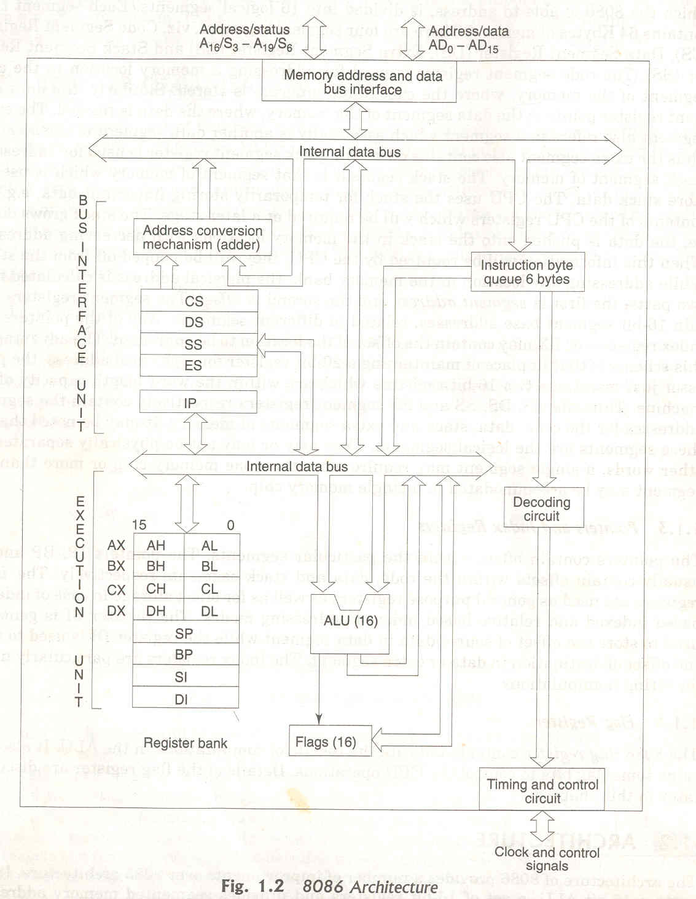
Execution Unit : The EU of 8086 tells the BIU where to fetch the instructions or data from, decodes instruction and fetches instruction. It contains an instruction decoder, control circuitry, ALU and a 16 bit flag register. It removes the instruction from the instruction queue.
Control Circuitry: The Circuitry directs the internal operations of the micro processor. The decoder translates instructions fetched from memory into a series of actions which the EU carries out. The EU has a 16 bit ALU which can add, subtract, AND, OR, XOR, increment, decrement, compliment or shift binary numbers. It generates all the control signals within the CPU. It initializes the registers on power up, generates the signal to fetch instructions for the ALU. The control unit may be implemented completely by the hardware (hard-wired controller eg: using a state counter and a programmable logic array) or a mixture of software instructions (microcode stored in the CPU) and hardware (micro-programmed control). The Intel 8086 family Motorola 68000 family, both use micro-programmed controllers.
Flag Registers: Flag is a flip-flop that indicates some condition produced by the execution of an instruction or controls certain operations of the EU. The 16 bit flag register contained 9 active flags. 6 out of 9 (CF, PF,AF,ZF,SF) are known as conditional flags and the other 3 (TF,IF,DF) are known as control flags.
15 11 10 8 6 4 2 0
Bit Definition of 8086 flag register.
The carry flag will be set to 1 if the addition of two 16-bit binary numbers produces a carry out of the MSB position. If no carryout of MSB is produced by the addition, then the carry flag will be zero. The EU, thus effectively runs up a flag to tell you that a carry was produced. Certain 8086 instructions check these flags to determine which of 2 alternative actions should be done in executing the instructions.
The control flags which control certain operations of the processor are TF, IF and DF. The conditional flags are set or reset by the EU on the basis of the result of some arithmetic or logic operations. The control flags are deliberately set or reset with specific instructions put in the program itself. TF or Trap flag is used for single stepping through the program. Interrupt flag is used to allow or prohibit the interruption of a program. Direction Flag is used with string operations.
General Purpose Registers(Multi-purpose Registers): EU has 8 general purpose registers, consist in four general purpose(multipurpose) registers labeled AX, BX, CX and DX, two stack pointers (SP and BP), and two index registers (SI and DI). These registers can be used individually or together for temporary storage of 8 or 16 bit data. The AX register is also called the accumulator.
Accumulator register consists of two 8-bit registers AL and AH, which can be combined together and used as a 16-bit register AX. AL in this case contains the low-order byte of the word, and AH contains the high-order byte. Accumulator can be used for I/O operations and string manipulation.
Base register consists of two 8-bit registers BL and BH, which can be combined together and used as a 16-bit register BX. BL in this case contains the low-order byte of the word, and BH contains the high-order byte. BX register usually contains a data pointer used for based, based indexed or register indirect addressing.
Count register consists of two 8-bit registers CL and CH, which can be combined together and used as a 16-bit register CX. When combined, CL register contains the low-order byte of the word, and CH contains the high-order byte. Count register can be used as a counter in string manipulation and shift/rotate instructions.
Data register consists of two 8-bit registers DL and DH, which can be combined together and used as a 16-bit register DX. When combined, DL register contains the low-order byte of the word, and DH contains the high-order byte. Data register can be used as a port number in I/O operations. In integer 32-bit multiply and divide instruction the DX register contains high-order word of the initial or resulting number.
The advantage of using internal registers for the temporary storage of data is that, since the data is already in the EU, it can be accessed much more quickly than it could be accessed in external memory.
Bus Interface Unit: BIU sends out addresses, fetches instruction from the memory, reads data from ports & memory and writes data to ports and memory. In general BIU handles all transfers of data and addresses on the buses for the execution unit. This unit is made of four segment registers (DS, CS, SS and ES), a program counter (IP - Instruction Pointer), and a 6-byte queue to store the pre-fetched instructions.
The queue: While the EU is decoding an instruction or executing an instruction which does not require use of the buses, the BIU fetches upto 6 instruction bytes from the memory unit. BIU stores these pre-fetched bytes in a FIFO register set called queue. When the EU is ready for its next instruction, it simply reads the instruction bytes for the instruction from the queue in the BIU. This is much faster then sending out an address to the system memory & waiting for memory to send back the next instruction byte or bytes. The queue is dumped and then reloaded starting from a new address, this pre-fetch and queue scheme greatly speeds up processing. Fetching the next instruction while the current instruction executes is called pipelining. So the instruction fetch and execution are pipelined parallel processing.
Segment Registers: The 8086 BIU sends out 20 bit addresses so it can address any of the 2 20 or 1048576 bytes of memory. At any given time 8086 works with only four 64 KB segments within this 1MB range. The 4 segment registers in the BIU are used to hold the upper 16 bits of the starting address of 4 memory segments that the 8086 is working with at a particular time.
- Code segment(CS) register: Holds the upper 16-bits of the starting address for the segment from which the BIU is currently fetching instruction code bytes. BIU always inserts ‘0’ for the lowest 4 bits of the 20 bit starting address for a segment. The part of a segment starting address stored in a segment register is often called the segment base.
- Stack segment (SS) register: The stack is a section of memory set aside to store addresses and data while a sub program executes. The SS register is used to hold the upper 16-bits of the starting address for the program stack.
- Extra Segment (ES) and Data Segment (DS) registers: These are used to hold the upper 16 bits of the starting address of 2 memory segments that are used for data.
Instruction Pointer (IP): The IP register holds the 16-bit address or offset of the next code byte within this code segment. The value in IP is offset from( added to) the segment base address in CS to produce the required 20-bit physical address sent out by BIU. So, the CS points to the base or start of the current code segment. IP contains the distance or offset from this base address to the next instruction byte to be fetched.
Eg:
CS 4589 IP 1324
Physical Address : 46BB4H OR 4589:1324
Stack Segment and Stack Pointer Registers: The upper 16-bits of the starting address for stack segment are kept in the stack segment register. The stack pointer register (SP) in the EU holds the 16 bit offset from the start of the segment to the memory location where a word was most recently stored on the stack (that position is termed as top of the stack). The physical address of the stack is represented as SS:SP
Pointer & Index Registers in the EU: The 16-bit registers BP, SI and DI can be used for temporary storage of data just as the general purpose registers. Their main purpose is to hold the 16-bit offset of the data word in one of the segments. The 16-bit default segment & offset registers are as follows:

Segment Offset Special Purpose
CS IP Instruction Address
SS SP or BP Stack Address
DS BX,DI,SI Data Address
ES DI (for string instructions) String Destination Address

PIN DIAGRAM OF 8086 MICROPROCESSOR:

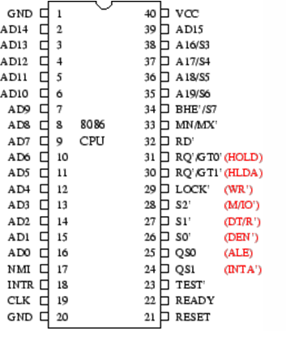
The 8086 signals can be classified into three groups:

- Signals having common function in both minimum mode and the maximum mode.
- Signals having special function for the minimum mode.
- Signal having special functions for the maximum mode.

Following are the signals having common function in both minimum mode and the maximum mode:

AD₁₅-AD₀ :
  - These are time multiplexed memory I/O address and data lines.
  - Address remains in the line during T1 state and data is available in the data bus during T2,T3,Tw and T4.
  - These lines are active high, tri-state lines.

A₁₉/S₆, A₁₈/S₅, A₁₇/S₄, A₁₆/S₃:
- These are time multiplexed data lines and status lines.
- During I/O operations, these lines are low.
- The S₄ and S₃ combined, indicate which segment registers is being currently used for memory access.
- These are also tri-state lines.
- The status line S₆ is always low.
- The address bits are separated from the status bits using latches controlled by the ALE signal.

BHE’/ S₇₋Bus High Enable Status:
- It is used to indicate the transfer of data over the higher order(D₁₅-D₈).
- It goes low for the data transfers over D₁₅ and D₈ used to derive chip selects of odd address memory bank or peripherals.
- The signal is low and tri-stated durint he hold state.

RD’-Read:
- This signal, when low, indicates the peripherals that the processor id performing a memory or I/O read operation.
- It is an active low signal.
- This signal remains tri-stated during the hold acknowledge.

READY:
- This is the acknowledgement from the slow devices or the memory that they have completed the data transfer.
- This is an active high signal.

INTR-Interrupt Request:
- This is a level triggered input.
- This is sampled during the last clock cycle of each instruction to determine the availability of the request.
- If any interrupt request is pending, the processor enters the interrupt acknowledge cycle.
- This signal is active high and internally synchronized.

TEST’:
- This input is examined by a WAIT instruction.
- If this signal goes low, execution will continue. Otherwise the processor remains in an idle state.

NMI-Non Maskable Interrupt:
- This is an edge triggered input which causes a type2 interrupt.
- The NMI is not maskable internally by software.
- This input is internally synchronized.

RESET:
- This input causes the processor to terminate the current activity and start execution from FFFF0H.
- This signal is active high and must be active for at least four clock cycles.
- It restarts execution when the RESET returns low.
- RESET is also internally synchronized.

CLK-Clock:
- The clock input provides the basic timing for processor operation and bus control activity.
- It is an asymmetric square wave with 33% duty cycle.
- The range of frequencies for different versions of 8086 varies from 5MHz to 10MHz.

Vcc:
- +5V power supply for the operation of the internal circuit.

GND:
- Ground for the internal circuit.

MN/MX:
- The logic level of this pin decides whether the processor has to work in the minimum mode (single processor) or the maximum mode (multi processor).

The following pin functions are for the minimum mode operation of 8086:

M/I/O’:
- This is a status line logically equivalent to S₂’ in the maximum mode.
- When it is low, it indicates that the CPU is having an I/O operation and when it is high, it indicates that the CPU is having a memory operation.

INTA’-Interrupt Acknowledge:
- This signal is used as read strobe for interrupt acknowledge cycles.
- When it goes low, the processor has accepted an interrupt.
- It invites the interrupting device to place the incoming vector on to the data line.

ALE-Address Latch Enable:
- This is an output signal.
- It indicates the availability of a valid address on the address/data line.
- It is connected to the latch enable input of latches.
- The signal is active is active high and is never tri-stated.

DT/R’-Data Transmit/Receive:
- This is used to determine the direction of data flow the trans-receivers.
- When the processor sends out data, the signal is high and when the processor is receiving data, the signal is low.
- It is tri-stated during the hold acknowledge.
- Logically, this signal is equivalent to S₁’ in maximum mode.

DEN’-Data Enable:
- This signal indicates the availability of valid data over the address/data lines.
- It is used to enable the trans-receivers to separate the data from the multiplexed address/data signal.
- This signal is tri-stated during the hold acknowledge cycle.

HOLD/HLDA-Hold/Hold Acknowledge:
- When the HOLD line goes high, it indicates to the processor that, another master is requesting the bus access.
- The processor, after receiving the HOLD request, issues the hold acknowledge signal on HLDA pin.
- When the processor finds that the HOLD line is low, it lowers the HLDA signal.
- HOLD is an asynchronous input and should be externally synchronized.

Following are the signals applicable for the maximum mode operation of 8086:

S2’, S1’, S0’-Status Lines:
- These are status lines which reflect the type of operation, being carried out by the processor.
S₂’ | S₁’ | S₀’ | Indication
0  0  0  0  1  1  1  1 | 0  0  1  1  0  0  1  1 | 0  1  0  1  0  1  0  1 | Interrupt Acknowledge  Read I/O port  Write I/O port  Halt  Code Access  Read Memory  Write Memory  Passive

LOCK’:
- This is an active low signal.
- This pin indicates that other system bus masters will be prevented from gaining the system bus, while the LOCK’ signal is low.
- This pin is activated by the LOCK prefix instruction and remains active until the completion of the next instruction.

QS₁, QS₀-Queue Status:
- These lines give information about the status of the code pre-fetch queue.
- These are active during clock the cycle after which the queue operation is performed.
QS₁ | QS₀ | Indication
0  0  1  1 | 0  1  0  1 | No operation  First byte of opcode from the queue  Empty queue  Subsequent byte from the queue

RQ’/GT₀’, RQ’/GT₁’-Request/Grant:
- These pins are used by other local bus masters, in maximum mode to force the processor to release the local bus at the end of the processor’s current bus cycle.
- Each of the pin is bi-directional with RQ’/GT₀’ having higher priority than RQ’/GT₁’.

Addressing modes

Addressing modes indicate a way of locating data or operands. An addressing mode specifies how to calculate the effective memory address of an operand by using information held in registers and/or constants contained within a machine instruction. It describes the type of operands and the way they are accessed for execution of an instruction.

1) Direct (Displacement only) Addressing Mode
The most common addressing mode is the displacement-only (or direct) addressing mode. In this addressing mode, a 16-bit memory address (offset) is directly specified as part of the instruction..

The instruction MOV AL, DS:[8088H] loads the AL register with a copy of the byte at memory location 8088H. Likewise, the instruction MOV [1234H], DS:DL stores the value in the DL register to memory location 1234H.

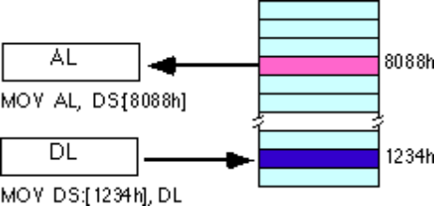
The displacement-only addressing mode is perfect for accessing simple variables.
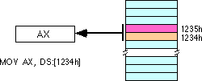

By default, all displacement-only values provide offsets into the data segment. If we want to provide an offset into a different segment, we must use a segment override prefix before the address. For example, to access location 1234H in the extra segment (ES) we would use an instruction of the form MOV AX, ES:[1234H]. Likewise, to access this location in the code segment we would use the instruction MOV AX, CS:[1234H]. The DS: prefix in the previous examples is not a segment override.

Immediate addressing mode

In this type of addressing, immediate data is a part of instruction, and appears in the form of successive byte or bytes.
Eg: MOV AX,0005H

Here 0005H is an immediate data. The data can be 8 bit or 16 bit.

Register addressing mode
In register addressing mode, the data is stored in a register and it is referred using the particular register. All the registers, except IP can be used for this purpose.

Eg: MOV AX, BX

4) The Register Indirect Addressing Modes

Sometimes, the address of the memory location that contains data or operand is determined by in an indirect way using the offset registers. This mode of addressing mode is known as register indirect addressing mode. Here, the offset address of data is in either BX or SI or DI

There are four forms of this addressing mode on the 8086, best demonstrated by the following instructions:
mov al, [bx]
mov al, [bp]
mov al, [si]
mov al, [di]

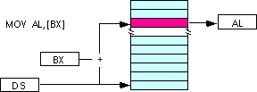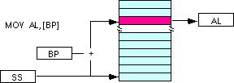
Note: the [si] and [di] addressing modes work exactly the same way, just substitute si and di for bx above.

Indexed Addressing Modes

In this mode of addressing, offset of the operand is stored in one of the index registers. DS and ES are the default segments for index registers SI and DI respectively.
The indexed addressing modes use the following syntax:

mov al, disp[bx]
mov al, disp[bp]
mov al, disp[si]
mov al, disp[di]

If bx contains 1000h, then the instruction mov cl,20h[bx] will load cl from memory location ds:1020h. Likewise, if bp contains 2020h, mov dh,1000h[bp] will load dh from location ss:3020.
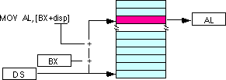

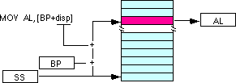

We may substitute si or di in the figure above to obtain the [si+disp] and [di+disp] addressing modes.
6) Register Relative

In this addressing mode, the data is available at an effective address formed by adding an 8-bit or 16-bit displacement with the content of any one of the registers BX, BP, SI and DI. in the default segment.
Eg: MOV AX, 50H[BX]

The effective address is given as 10H * DS + 50H + [BX]
7) Based Indexed Addressing Modes

The based indexed addressing modes are simply combinations of the register indirect addressing modes. The effective address is calculated by adding the content of base register (bx or bp) to the content of an index register (si or di).
Eg: MOV AX, [BX] [SI]

Effective address is computed as 10H * DS + [BX] + [SI]
The allowable forms for these addressing modes are

mov al, [bx][si]
mov al, [bx][di]
mov al, [bp][si]
mov al, [bp][di]

Suppose that bx contains 1000h and si contains 880h. Then the instruction
mov al,[bx][si]

would load al from location DS:1880h. Likewise, if bp contains 1598h and di contains 1004, mov ax,[bp+di] will load the 16 bits in ax from locations SS:259C and SS:259D.
The addressing modes that do not involve bp use the data segment by default. Those that have bp as an operand use the stack segment by default.
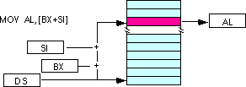
By substituting di in the figure above, we can obtain the [bx+di] addressing mode.
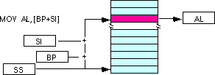

We substitute di in the figure above for the [bp+di] addressing mode.

8) Based Indexed Plus Displacement Addressing Mode
These addressing modes are a slight modification of the base/indexed addressing modes with the addition of an eight bit or sixteen bit constant. The following are some examples of these addressing modes:

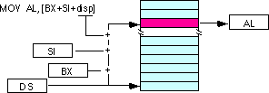
mov al, disp[bx][si]
mov al, disp[bx+di]
mov al, [bp+si+disp]
mov al, [bp][di][disp]

di may be substituted in the figure above to produce the [bx+di+disp] addressing mode.

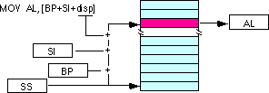

Suppose bp contains 1000h, bx contains 2000h, si contains 120h, and di contains 5. Then mov al,10h[bx+si] loads al from address DS:2130; mov ch,125h[bp+di] loads ch from location SS:112A; and mov bx,cs:2[bx][di] loads bx from location CS:2007.

Control flow instruction addressing modes

- Intersegment mode
If the location to which control is to be transferred lies in a different segment other than the current one, the mode is called intersegment mode.

- Intrasegment mode

If the destination location lies in the same segment, the mode is called intrasegment mode.

Intrasegment direct

Intrasegment
Modes for control
Intrasegment Indirect
Transfer instructions Intersegment Direct
Intersegment

Intersegment Direct Four types:

- Intrasegment Direct Mode

In this mode, the address to which the control is to be transferred lies in the same segment in which the control transfer instruction lies and appears directly in the instruction as an immediate displacement value. In this mode, the displacement is computed relative to the content of the instruction pointer IP.
The effective address to which control is transferred is given by the sum of 8 or 16 bit displacement and current content of IP. In case of jump instruction, if the signed displacement (d) is of 8 bits (-128<d<+128), we term it as short jump and if it is of 16 bits, it is termed as long jump.

- Intra segment Direct Mode
In this mode the displacement to which the control is to be transferred is in the same segment in which the control transfer instruction lies, but it is passed to the instruction indirectly. Here, the branch instruction is found as the content of register or a memory location. This addressing mode may be used in unconditional branch instructions.

- Intersegment Direct Mode

In this mode, the address to which the control is to be transferred is in a different segment. The addressing mode provides a means of branching from one code segment to another code segment. Here the CS and IP of the destination address are specified directly in the instruction.

- Intersegment Indirect Mode

In this mode, the address to which the control is to be transferred is in a different segment and it is passed to the instruction indirectly, i.e contents of a memory block containing four bytes, i.e IP(LSB), IP(MSB), CS(LSB) and CS(MSB).The starting address of the memory block may be referred using any of the addressing mode, except immediate..

8088

Registers
Most of the registers contain data/instruction offsets within 64 KB memory segment. There are four different 64 KB segments for instructions, stack, data and extra data. To specify where in 1 MB of processor memory these 4 segments are located the processor uses four segment registers:

Code segment (CS) is a 16-bit register containing address of 64 KB segment with processor instructions. The processor uses CS segment for all accesses to instructions referenced by instruction pointer (IP) register. CS register cannot be changed directly. The CS register is automatically updated during far jump, far call and far return instructions.

Stack segment (SS) is a 16-bit register containing address of 64KB segment with program stack. By default, the processor assumes that all data referenced by the stack pointer (SP) and base pointer (BP) registers is located in the stack segment. SS register can be changed directly using POP instruction.

Data segment (DS) is a 16-bit register containing address of 64KB segment with program data. By default, the processor assumes that all data referenced by general registers (AX, BX, CX, DX) and index register (SI, DI) is located in the data segment. DS register can be changed directly using POP and LDS instructions.
Extra segment (ES) is a 16-bit register containing address of 64KB segment, usually with program data. By default, the processor assumes that the DI register references the ES segment in string manipulation instructions. ES register can be changed directly using POP and LES instructions.
It is possible to change default segments used by general and index registers by prefixing instructions with a CS, SS, DS or ES prefix.
All general registers of the 8088 microprocessor can be used for arithmetic and logic operations. The general registers are:
Accumulator register consists of 2 8-bit registers AL and AH, which can be combined together and used as a 16-bit register AX. AL in this case contains the low-order byte of the word, and AH contains the high-order byte. Accumulator can be used for I/O operations and string manipulation.
Base register consists of 2 8-bit registers BL and BH, which can be combined together and used as a 16-bit register BX. BL in this case contains the low-order byte of the word, and BH contains the high-order byte. BX register usually contains a data pointer used for based, based indexed or register indirect addressing.
Count register consists of 2 8-bit registers CL and CH, which can be combined together and used as a 16-bit register CX. When combined, CL register contains the low-order byte of the word, and CH contains the high-order byte. Count register can be used as a counter in string manipulation and shift/rotate instructions.
Data register consists of 2 8-bit registers DL and DH, which can be combined together and used as a 16-bit register DX. When combined, DL register contains the low-order byte of the word, and DH contains the high-order byte. Data register can be used as a port number in I/O operations. In integer 32-bit multiply and divide instruction the DX register contains high-order word of the initial or resulting number.

The following registers are both general and index registers:

Stack Pointer (SP) is a 16-bit register pointing to program stack.

Base Pointer (BP) is a 16-bit register pointing to data in stack segment. BP register is usually used for based, based indexed or register indirect addressing.

Source Index (SI) is a 16-bit register. SI is used for indexed, based indexed and register indirect addressing, as well as a source data address in string manipulation instructions.

Destination Index (DI) is a 16-bit register. DI is used for indexed, based indexed and register indirect addressing, as well as a destination data address in string manipulation instructions.
Other registers:

Instruction Pointer (IP) is a 16-bit register.
Flags is a 16-bit register containing 9 1-bit flags:
- Overflow Flag (OF) - set if the result is too large positive number, or is too small negative number to fit into destination operand.
- Direction Flag (DF) - if set then string manipulation instructions will auto-decrement index registers. If cleared then the index registers will be auto-incremented.
- Interrupt-enable Flag (IF) - setting this bit enables maskable interrupts.
- Single-step Flag (TF) - if set then single-step interrupt will occur after the next instruction.
- Sign Flag (SF) - set if the most significant bit of the result is set.
- Zero Flag (ZF) - set if the result is zero.
- Auxiliary carry Flag (AF) - set if there was a carry from or borrow to bits 0-3 in the AL register.
- Parity Flag (PF) - set if parity (the number of "1" bits) in the low-order byte of the result is even.
- Carry Flag (CF) - set if there was a carry from or borrow to the most significant bit during last result calculation.
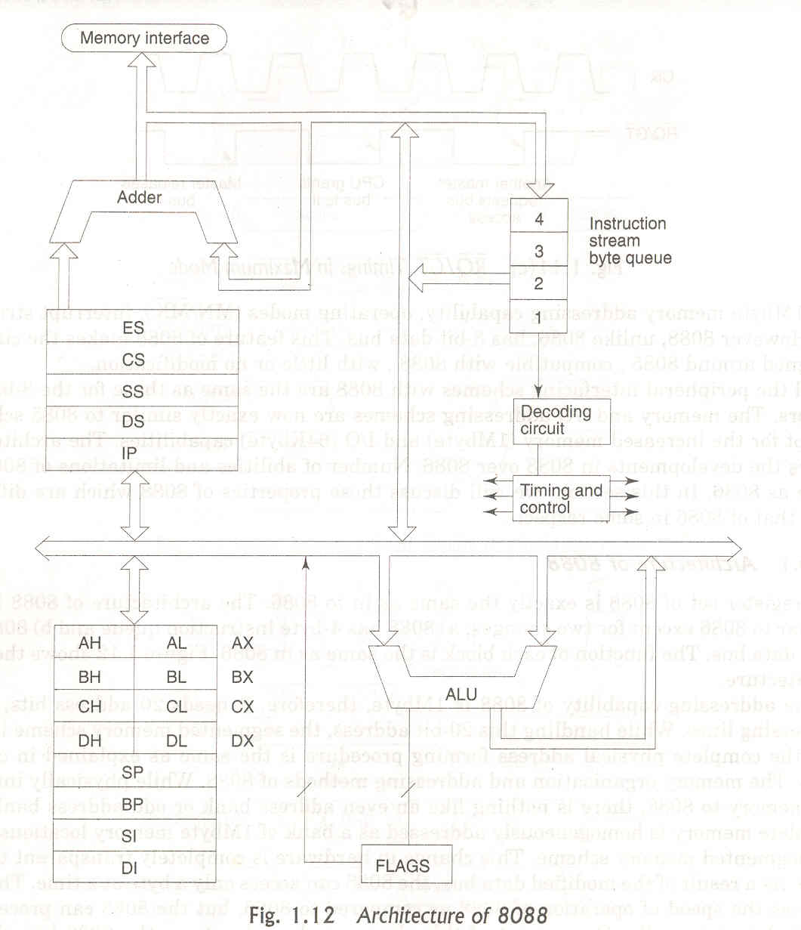

Difference between 8088 and 8086

- The 8086 has 16 bit data bus; the 8088 has an 8 bit data bus.
- The 8086 has a 6 byte instruction queue, and the 8088 has a 4 byte queue.
- The 8088 was the chip used in the first IBM PC; the 8086 wasn't used until later models. Since they share the exact same instruction set, which is referred to as the "x86 instruction set" these days, this is often confused.

